231901005

Identity and Access Management

EX-NO:03

AIM:

Learn about identification, authentication, authorisation, accounting, and identity management.

PROCEDURE:

* Introduction
* IAAA Model
* Identification

# • Authentication

* Authorization and Access Control
* Accountability and Logging
* Identity Management
* Attacks against Authentication
* Access Control Models
* Single Sign-On
* Scenarios
* Conclusion

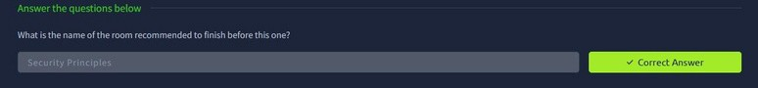

Task 2:

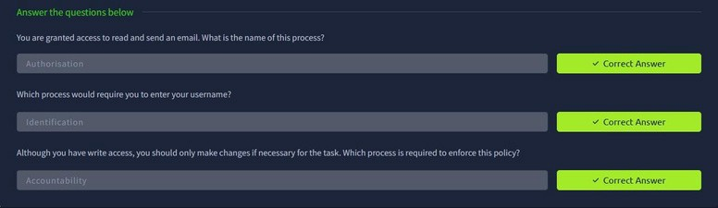

Task 3:

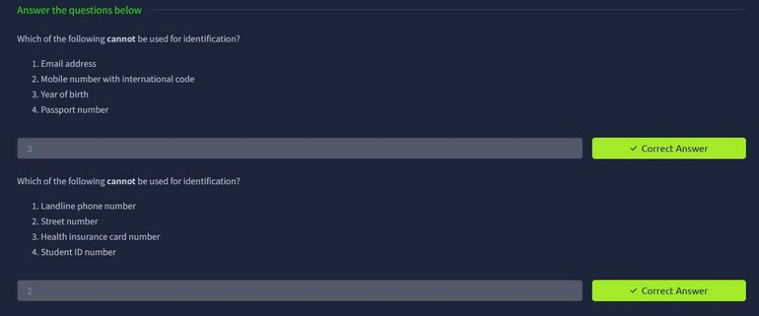

Task 4:

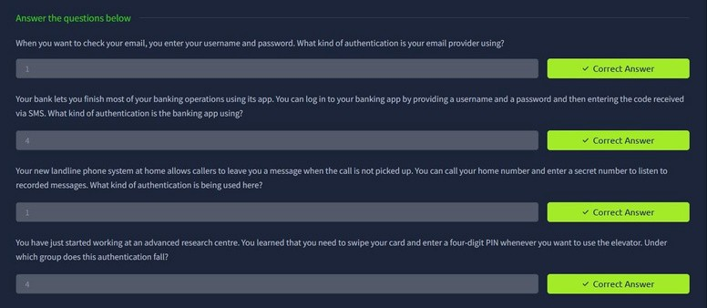

Task 5:

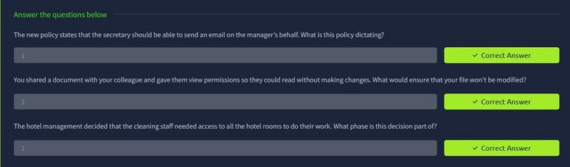

Task 6:

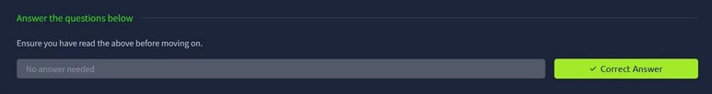

Task 7:

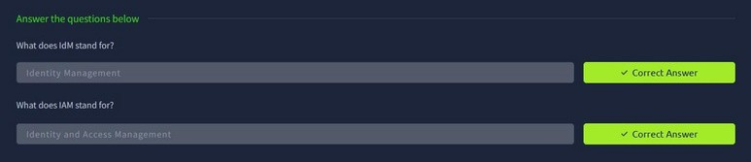

Task 8:



Task 9:

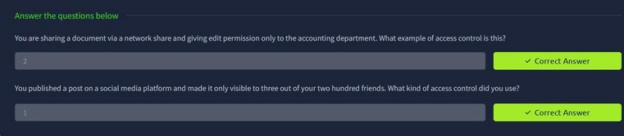

Task 10:

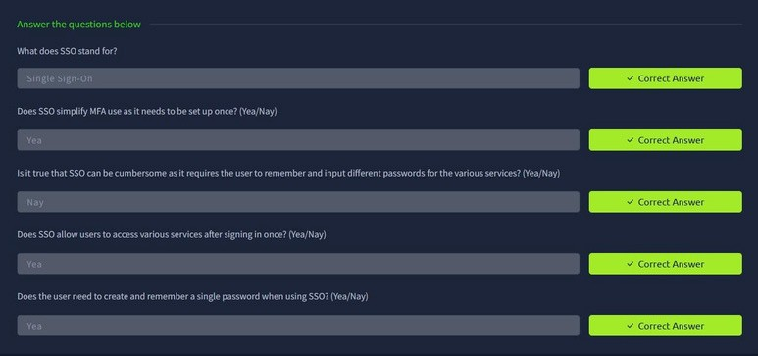

Task 11:



Task 12:

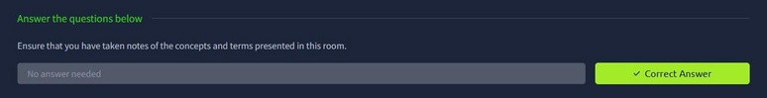

RESULT:

Thus the Identity and Access Management successfully completed in tryhackme platform.